Aug 31, 2026

Genailakes usecase
Invited mukund_shindikar@satven.com Phani Kumar csr@genailakes.com
Attachments Genailakes usecase
Meeting records Transcript

Summary
The team assessed prototype capabilities and narrowed the strategic focus to automotive-specific engineering and molding analysis.
Prototype Capabilities Review
Demonstrated functionality included 3D to 2D and 2D to 3D conversion tools leveraging cloud infrastructure and Retrieval Augmented Generation. Technical proficiency was confirmed regarding engineering data processing.
Engineering Data Requirements
Feedback shifted the project focus from generic propeller models to relevant automotive components like disc brakes. Injection molding analysis involving undercuts and lifters became a prioritized functional requirement.
Strategic Feature Alignment
Prioritizing 3D to 2D conversion and molding analysis streamlines development cycles. Insufficient precision standards necessitated de-prioritizing the live camera dimensioning feature.

Decisions
Aligned
- Disc brake selected as test case The team will prioritize the disc brake model as the relevant test case for automotive validation, shifting focus away from the impeller model.
- Collaboration focus areas defined The collaboration will exclusively focus on two specific development areas: 3D data to 2D engineering drawing conversion and step file analysis for molding directions and undercuts.
- Collaboration site visit planned The teams agreed to schedule an in-person working session, tentatively for the following Monday or Tuesday, to collaborate on defined requirements using real data.

Next steps
- [Phani Kumar, Aaryan Goud Konda] Explore Brake Data: Test the prototype system using disk brake files to identify performance outcomes. Analyze findings to understand relevance for automotive applications.
- [Mukund Shindikar] Coordinate Next Steps: Consult with management to finalize the project collaboration plan. Determine the feasibility of the proposed technical areas.
- [Mukund Shindikar] Schedule Onsite Sessions: Organize a time for the team to visit the office on next Monday or Tuesday. Assign a team member to provide technical guidance and requirements.
- [Phani Kumar, Aaryan Goud Konda] Refine Technical Focus: Prioritize development of features for 3D to 2D drawing conversion and molding direction analysis. Ensure these enhancements meet the specified requirements for plastic parts and undercuts.

Details
- Introduction and Team Capabilities: Mukund Shindikar, Phani Kumar, and sreevikranth deva confirmed that the development team possesses the proficiency to download datasets and create applications using retrieval-augmented generation (00:10:41).
- Proposed Project Use Cases: Phani Kumar outlined four primary use cases for the prototype: converting 3D computer-aided design (CAD) to 2D engineering drawings, converting 2D engineering drawings to 3D CAD, implementing a retrieval-augmented generation engine, and utilizing a live camera for object dimensioning (00:11:55).
- 3D CAD to 2D Conversion Demo: Phani Kumar demonstrated the 3D-to-2D conversion process using a wind propeller sample file sourced from Kaggle (00:14:19). The system utilized FreeCAD to process step files, rendering the 3D design and generating a 2D technical drawing sheet with multiple views and section cuts (00:16:41).
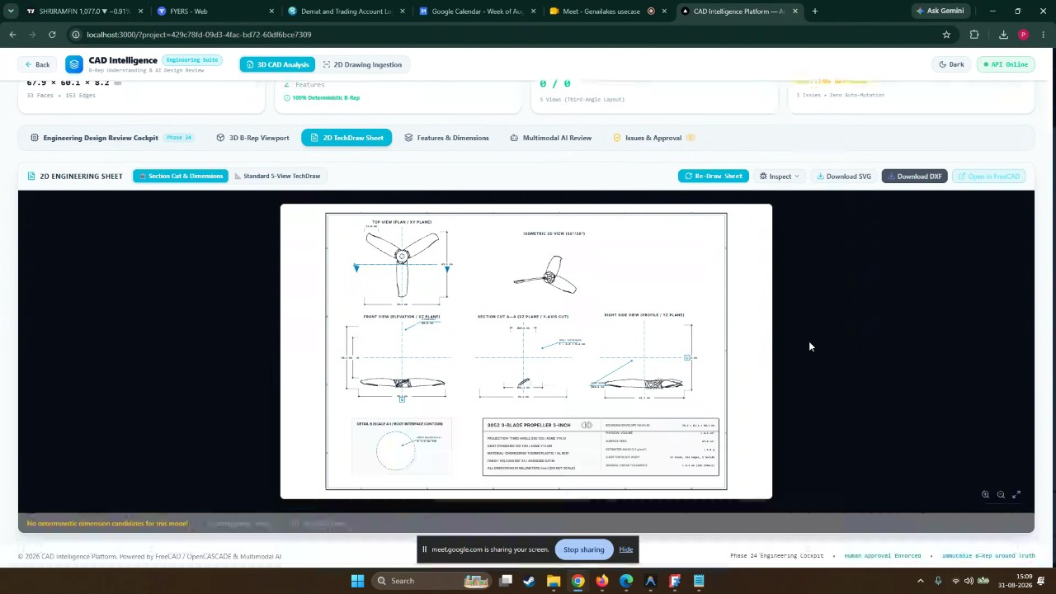
- Technical Data Extraction and AI Validation: Phani Kumar explained that length, breadth, and thickness dimensions are extracted directly from the step file's coordinate and vector data, which can contain between 2,300 and 18,000 lines of data (00:18:52). The system incorporates AI to perform validation checks on the generated drawings, suggest enhancements like adding blade cord lengths or angles, and provide a multi-model review for human approval (00:21:18).
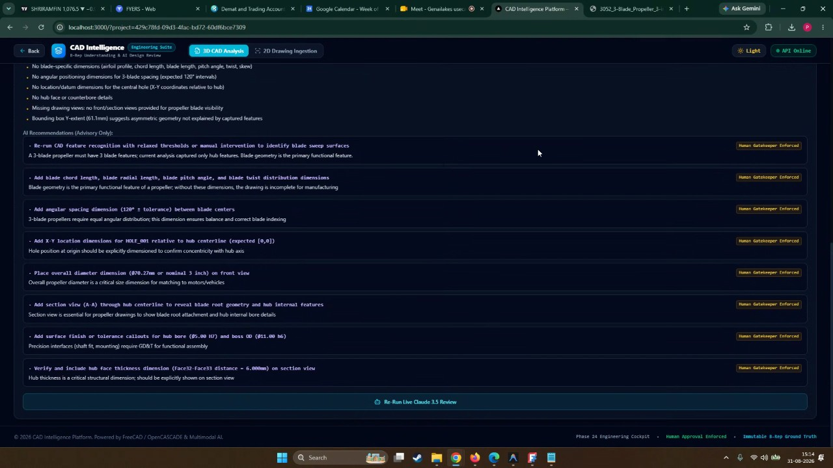
- Automotive Data Relevance: Mukund Shindikar expressed concern regarding the relevance of the wind propeller example to the automotive industry (00:23:57) (00:34:12). Mukund Shindikar requested that the team shift focus to more pertinent data, such as a disc brake, to test the system's capabilities against more realistic engineering scenarios (00:25:10) (00:34:12).
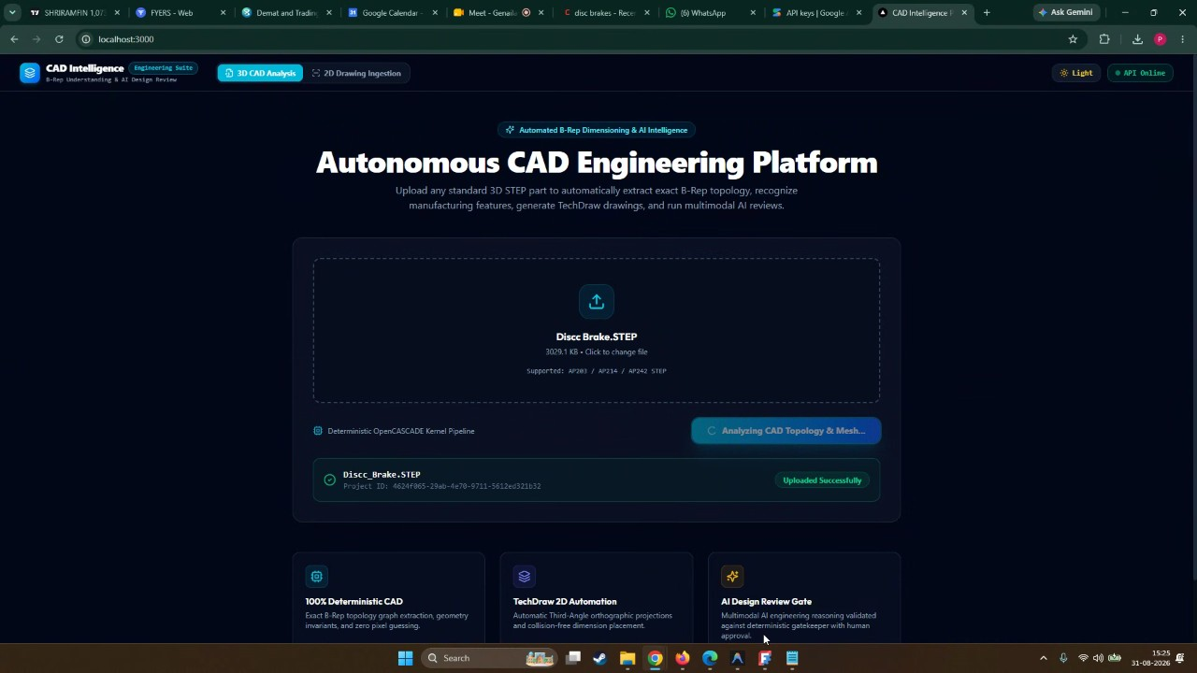
- 2D to 3D Conversion Demo: Aaryan Goud Konda presented the 2D-to-3D conversion process, where a 2D image is uploaded to generate a 3D model. The system uses topology to verify dimensions, identify faces and edges, and provide warnings if the 2D drawing lacks the necessary views or section cuts required for a complete 3D conversion (00:31:04).
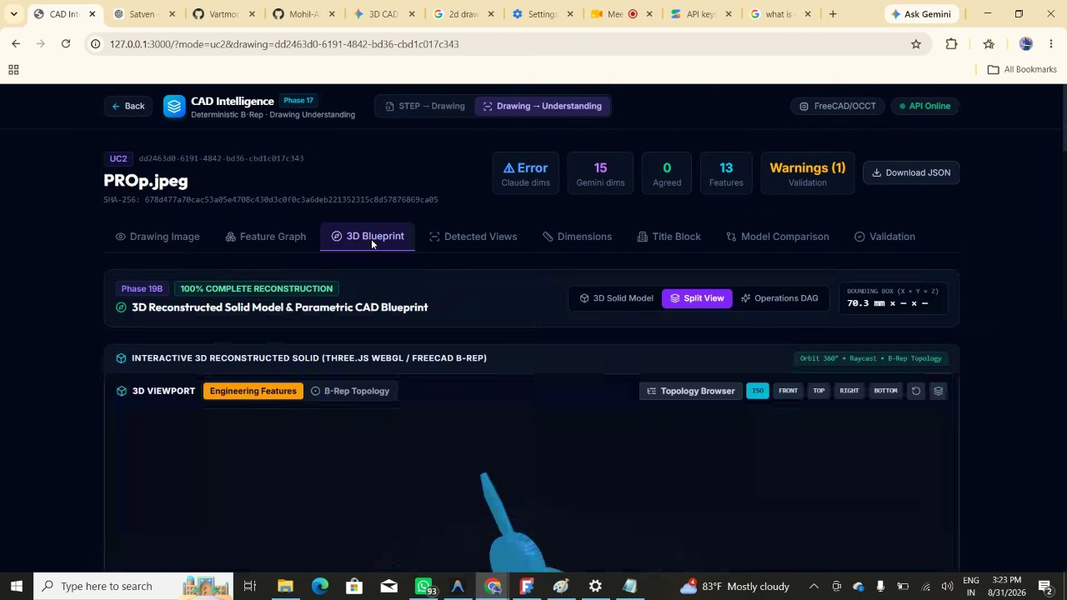
- Tooling and Molding Direction Analysis: Mukund Shindikar identified the analysis of molding directions, undercuts, and the design of sliders and lifters for injection-molded parts as a critical area of interest. Mukund Shindikar suggested that incorporating this specific logic, based on specialized Chinese and Taiwanese datasets, would make the prototype significantly more valuable and presentable (00:37:17) (00:43:50).
- Infrastructure and Export Capabilities: Regarding infrastructure, sreevikranth deva confirmed the use of Amazon Web Services cloud virtual machines with GPU support (00:39:22). Phani Kumar noted that the system supports exporting drawings in SVG, JSON, and DXF formats (00:40:19).
- Live Camera Dimensioning Review: Phani Kumar demonstrated a live camera dimensioning feature; however, Mukund Shindikar noted that automotive requirements often demand precision at the micron level, making standard camera-based measurement less suitable (00:42:53). Mukund Shindikar advised that the team could continue developing this feature as their own initiative, though it was not a primary area of interest for the immediate collaboration (00:43:50).
- Future Collaboration and Scheduling: Mukund Shindikar stated a clear interest in collaborating on 3D-to-2D creation and molding direction analysis (00:43:50). Mukund Shindikar suggested that the team work offline to refine the disc brake test case and prepare for in-person collaboration sessions. The participants planned to coordinate a time for the team to visit, likely around the following Wednesday or Monday, to align on real data and requirements (00:50:58).
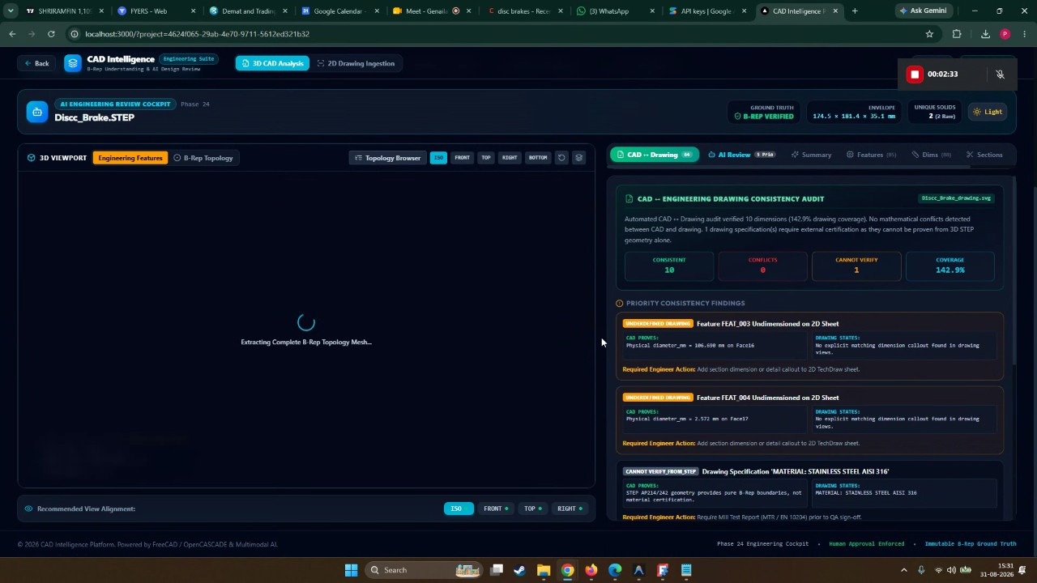

You should review Gemini's notes to make sure they're accurate. Get tips and learn how Gemini takes notes
How is the quality of these specific notes? Take a short survey to let us know your feedback, including how helpful the notes were for your needs.

